Product Design Specification
- Title
  - Product Design Specification - Pokemon card case design
- Introduction & Background Information
    - It is required to design a case which is able to hold cards for the Pokemon card trading game.
    - As a design engineer your job is to produce a playing cards case. The product must be fully functional which allows the end user to store playing cards securely. The product must involve an aesthetic appeal which includes elements complementing the franchise. In addition, it is required to design the product in 2 different design representations (B-rep & CSG) and 2 different CAD packages.
- Definitions
  - General abbreviations
    - Project: An effort to create a final usable product with the aid of tools such as PDS, CAE, CAD, etc.
    - 3D: 3 Dimensions
    - 2D: 2 Dimensions
    - 1D: 1 Dimension
    - Card: A singular printed flat piece of stiff paper
    - Concept: An initial idea of a product or part
  - Engineering abbreviations
    - PDS: Product Design Specification
    - BoM: Bill of Materials.
    - CAD: Computer Aided Design
    - CAGD: Computer Aided Geometric Design
    - CNC: Computer Numerated Control
    - FFF: Fused Filament Fabrication
    - AM: Additive Manufacturing
    - Drawing: Technical drawing; draft.
    - ISO: International Organisation for Standardisation
    - BSI: British Standards Institution
  - Symbols
    - mm: millimetres
    - cm: centimetres
    - A4: page size of 210mm x 297mm
  - Assembly
    - Part: An independent solid body.
    - Shell: Outer static part which constitutes the entire assembly.
    - Liner: Inner part located at the bottom of the shell - this is the part where the cards will sit in.
    - Lid: A singular part which is dynamic and sits on top of the shell on either the left or right.
    - Hinge: This is a simple part which is designed to make the lid dynamic allowing it to pivot around a point.
    - Assembly: A completed product consisting of a liner, shell, 2 lids, and 4 hinges.
  - Measurements
    - Height: Total height of the assembly with its lids closed.
    - Width: Total width of the assembly with its lids closed.
    - Depth: Total depth of the assembly.
    - Max height: Total height of the assembly with its lids fully open.
    - Max width: Total width of the assembly with its lids fully open.
  - Features and surfaces
    - Base: The bottom surface of a local part or assembly.
    - Top: The top surface of a local part or assembly.
    - Front: The front surface of a local part or assembly.
    - Back: The back surface of a local part or assembly.
    - right: The right surface of a local part or assembly.
    - Left: The left surface of a local part or assembly.
    - Pokeball: Split feature located in the front and back of the shell.
  - Manufacturing
    - 3D printer: A CNC FFF AM machine used for fabrication.
- Scope
  - General
    - The PDS must allow for cross referencing.
    - The PDS must ensure that photos shall have sufficient lighting on a white background.
    - Design efforts shall be completed in FreeCAD, Solidworks, Open SCAD.
    - Design efforts shall make use of CSG methods.
    - Design efforts within
  - Product assembly
    - The assembly must use a hybrid representative modelling approach, blending in b-rep and CSG methods.
    - The assembly must be completed using top-down and bottom-up methods – initially using top-down.
    - The assembly must primarily utilise the CSG method. If an operation is impossible (i.e. surface split), use b-rep.
    - The liner must be the driver.
    - The shell, lids, and hinges must be driving.
    - It is beyond the scope to consider the Shelf life of the assembly.
    - It is beyond the scope to consider the performance of the assembly.
    - It is beyond the scope to consider the standard specifications such as BSI and ISO.
    - It is beyond the scope to consider the marketing of the assembly.
    - It is beyond the scope to consider the legal aspects of the assembly.
    - It is beyond the scope to consider the disposal methods of the assembly.
    - It is beyond the scope to consider the weight considerations of the assembly.
    - It is beyond the scope to consider the maintenance of the assembly.
    - It is beyond the scope to consider the ergonomics of the assembly.
    - It is beyond the scope to consider the testing of the assembly.
  - Manufacturing
    - The product shall be manufactured using AM FFF methods.
    - The product shall be converted into G-code for AM.
    - The product shall be constructed in bottom-up for G-code conversion.
- Time-scale
  - General
    - The PDS must be completed before 10th July 2026.
    - The project must be completed before 22th August 2026.
- Aesthetics
  - Features
    - Pokeball – Franchise logo positioned on the front and back (halved).
  - Colours
    - Base (shell & lids): Yellow.
    - Pokeball centre: White.
    - Pokeball outer: red (front), white (back).
    - Pokeball split: black.
    - Secondary (hinges & liner): red.
- Appendices
  - Appendix A: Card dimensions
    - Sample card front view
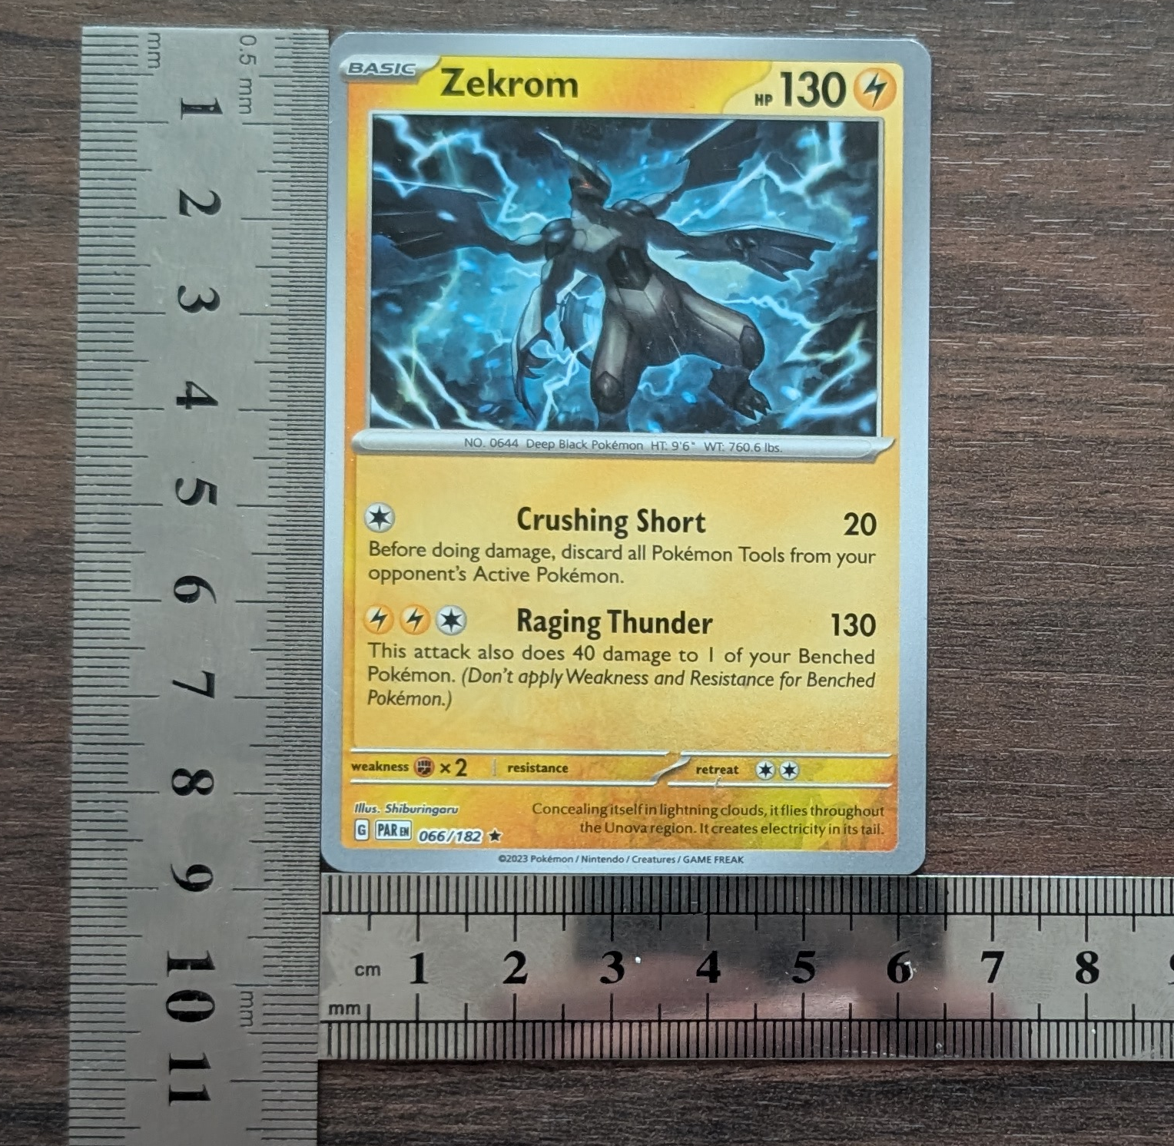
    - Dimensions drawing
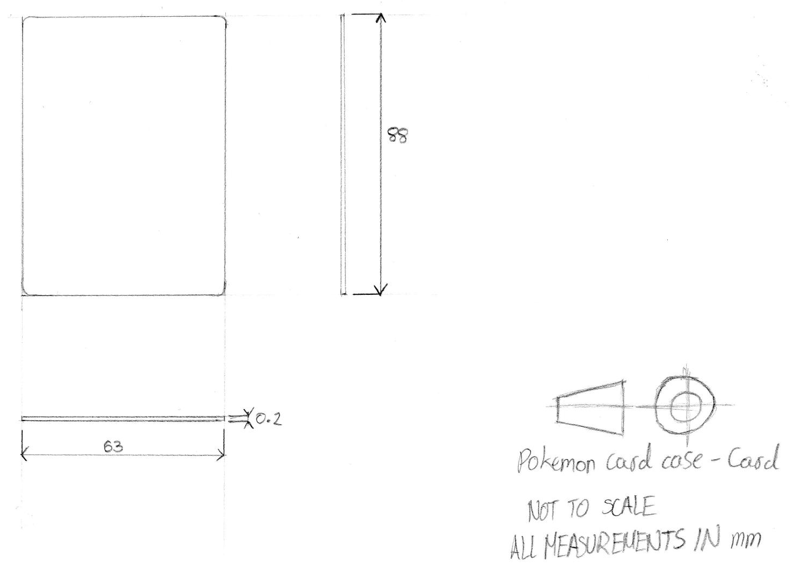
  - Appendix B: Liner basic dimensions
    - Dimensions drawing
